**Round 2 Phase 3 – Working Prototype**

Title: Stats Paper

Team: KIIT_BHUBANESWAR_Glitch

Qualitative and Quantitative Impact

In the age of data, the common consumer is distant from realizing the abilities of data science. Current channels of data (for consumers) like digital newspapers have not undergone the required changes. One such section in the current digital news platforms is finance which has huge potential to bring data science to its readers. It is always a struggle to take statistical information and present its analysis in an impactful manner to the reader.

To solve this problem and bring data science closer to everyday users we redesigned the skeleton of finance section of such digital platforms. We added current cutting-edge technologies like natural language processing models and machine learning algorithms to provide users a more vibrant experience.

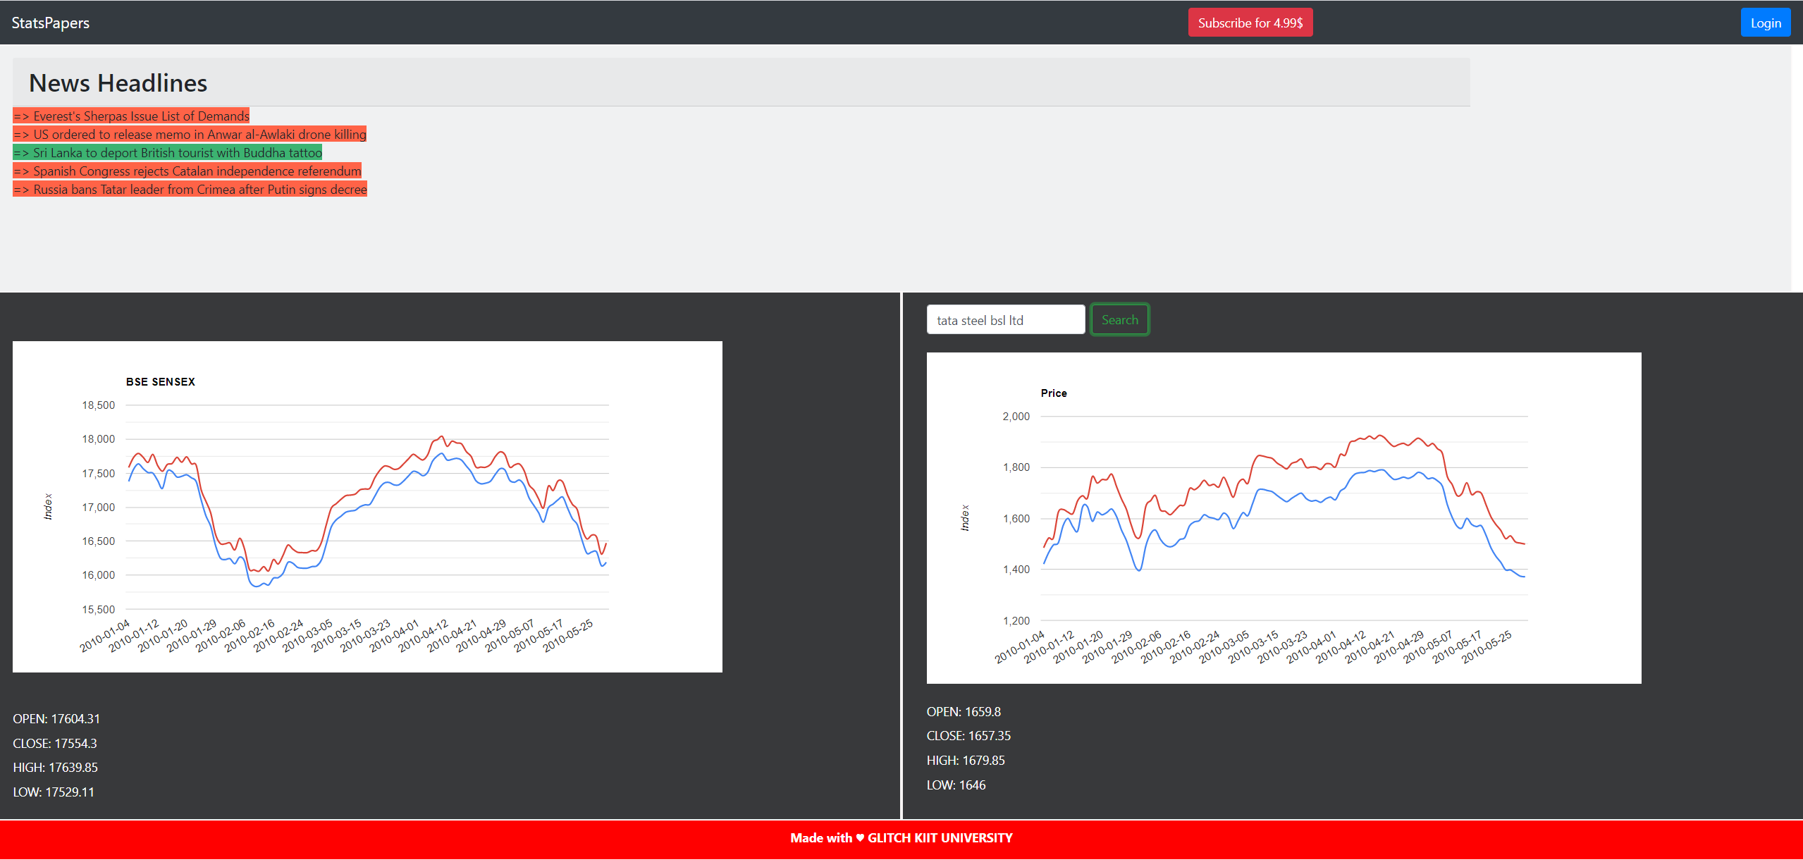

Fig: Screenshot of the website’s finance news section

Our solution includes:

* 100 days forecast of stock market index
* 100 days forecast of any company’s stock price
* Sentiment detection of the live news headlines
* Easy simple layout to grasp the important things
* More opportunities for improvement because of simple design

Newspapers are read across the world. With the current ongoing pandemic, digital world has become the new reality. Digital platforms that serves such services needs to be changed and ready with new technologies at the disposal of daily consumer.

The current solutions are either their but lack the right presentation or they are complex for a layman to understand. With our proposed solution we provided and prove that the current data science world can change the way we understand data. With our prototype we prove that how easy and simple it is to implement such algorithms.